**COURSE REGISTRATION SYSTEM**

**GROUP NAME:** INNOVATORS

**GROUP MEMBERS:** Akhila Yarlagadda, Sreekanth Kumar Vobilishetty, Piyusha Varshini Tirukovalluru, Meghana Reddy Akkati

**DESCRIPTION**

Course registration system is a website where students from various departments in a university can register for courses of their choice online.

This website allows only students enrolled in the university to login with his/her username and password. After a successful login, a student can manage his courses such as add/drop/swap courses.

**ADD** – A student can add as many courses as he wants to the shopping cart and finish enrolling in the courses which he/she chooses.

**DROP** - After enrolling in a class, a student can also drop a course if he/she decides to before the deadline.

**SWAP** – Similar to add/drop, a student can swap his existing class with some other class of his choice.

After enrolling, a student can view his class schedule which includes list of all the courses he has, their timings, location etc. Similarly, a student can also access the grades of all the completed courses.

**Programming languages:** Java Spring Boot, Javascript, HTML, CSS, JSP

**Development Environment:** Spring Tool Suite 4-4.2.0, Visual Studio, GitHub

**MEETING MINUTE DETAILS**

**MOM 1**

|  |  |
| --- | --- |
| DATE: | Thursday, Aug 29, 2019 |
| TIME: | 10:45 AM |
| LOCATION: | DP D215 |

* Meeting to discuss
  + Project to be taken for Group assignment.
  + Discussion on each individual team member projects.
* Attendee Names
  + Sreekanth, Akhila, Varshini, Meghana.
* Attendees not present
  + -

**MOM Points**

Discussed various projects suggested by the team.

* Sreekanth suggested Orderezi, Android application.
* Akhila Suggested Course Registration System, web application.
* Varshini suggested Invigilation management System.
* Meghana suggested Bus tracking system.

Reasons discussed on various project ideas are as follows: o Course Registration System: It’s a web application, everyone familiar with web technologies and want to go deep, so we chose this.

* Orderezi project: Android application, everyone not aware of Android.
* Invigilation management System project: Don’t have detailed idea about project.
* Bus tracking System: Android application, everyone not aware of Android.

Finally, we decided to develop Course Registration System.

# Action Plan

|  |  |  |  |
| --- | --- | --- | --- |
| S. No | Action items | Owner(s) | Deadline |
| 1. | To Understand GitHub, discuss Course registration system project | Sreekanth, Akhila, Varshini, Meghana | 09/03/2019 |

# Announcements

* By this MOM, we came up to take Course Registration System.

**MOM 2**

|  |  |
| --- | --- |
| DATE: | Tuesday, Sep 10, 2019 |
| TIME: | 10:45 AM |
| LOCATION: | DP D215 |

* Meeting to discuss
  + Technologies to be used.
  + Schedule and drawing PERT/GANTT charts.
  + Project Management tool.
* Attendee Names
  + Sreekanth, Akhila, Varshini, Meghana.
* Attendees not present
  + -

**MOM Points**

* Identified what technologies to be used in this application.
* Schedule was firmly placed and chose Project management tool.

# Action Plan

|  |  |  |  |
| --- | --- | --- | --- |
| S. No | Action items | Owner(s) | Deadline |
| 1. | Work on Deliverable- 1 | Sreekanth, Akhila, Varshini, Meghana | 09/12/2019 |

# Announcements

We are successful in choosing project management tool and scheduled on various aspects of project. Technologies used are decided.

**RISK MANAGEMENT**

**GENERIC RISKS**

1. **Schedule Risk:** Schedule risk is a most common risk in any software/web development projects. Schedule risk includes wrong time estimation, last minute change in requirements, resource unavailability difficulty in integration etc. All these risks lead to compromise in project deadline.

**Mitigation:** We first plan to accomplish the basic requirements of the system like system logic, exception handling, test cases etc. keeping track of the time availability. We also plan to integrate all parts of the code every now and then to confirm the compatibility. Later, we decide on developing additional/optional features.

**PROJECT SPECIFIC RISKS**

1. **Password storage risk:** If the admin password is compromised, there is a risk of whole website compromise and finance information leakage. If the password list of all students is stored directly in database, they can be accessed easily which may lead to accounts hack.

**Mitigation:** We plan to implement a password encryption mechanism while storing passwords in database.

1. **Ability to store and access curriculum information effectively:** As this project would include large curriculum information such as lot of departments, courses and their schedules, there is a high chance of confusion to store/access this information.

**Mitigation:** First, we analyze all the information like what all departments and courses we would have and provide unique codes for each course which may lower this risk.

**PERT CHART FOR PLAN**

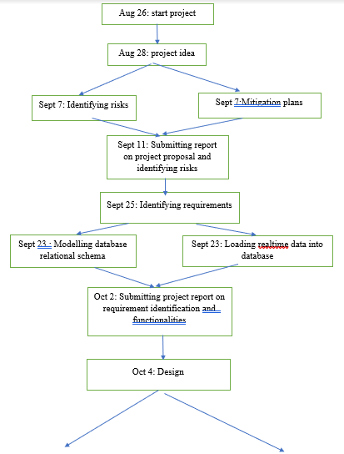

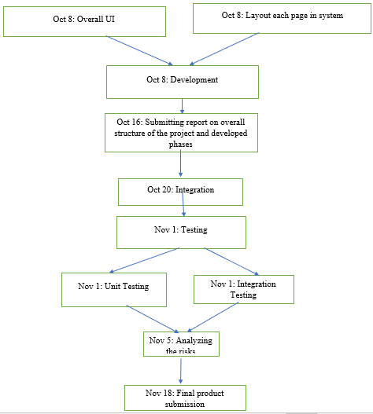

**RISK MANAGEMENT**

**GENERIC RISKS**

1. **Schedule Risk:** Schedule risk is a most common risk in any software/web development projects. Schedule risk includes wrong time estimation, last minute change in requirements, resource unavailability difficulty in integration etc. All these risks lead to compromise in project deadline.

**Mitigation:** We first plan to accomplish the basic requirements of the system like system logic, exception handling, test cases etc. keeping track of the time availability. We also plan to integrate all parts of the code every now and then to confirm the compatibility. Later, we decide on developing additional/optional features.

**PROJECT SPECIFIC RISKS**

1. **Password storage risk:** If the admin password is compromised, there is a risk of whole website compromise and finance information leakage. If the password list of all students is stored directly in database, they can be accessed easily which may lead to accounts hack.

**Mitigation:** We plan to implement a password encryption mechanism while storing passwords in database.

1. **Ability to store and access curriculum information effectively:** As this project would include large curriculum information such as lot of departments, courses and their schedules, there is a high chance of confusion to store/access this information.

**Mitigation:** First, we analyze all the information like what all departments and courses we would have and provide unique codes for each course which may lower this risk.

**TEAM MEMBERS ROLES AND RESPONSIBILITIES**

1. **SREEKANTH KUMAR VOBILISHETTY (SYSTEM ARCHITECT):** Represent technical team to delivery managers and leadership group. Plan complete system and communicate technical requirements with project managers and leadership group. Discuss internally regarding project imminent goals and place stand ups with delivery managers.
2. **AKHILA YARLAGADDA (TEAM LEAD):** Managing deliverables according to the schedule and plan. Lead the project and team. Design project schedule according to each phase of project life cycle. Update project status within team and to project manager. Assign tasks to project team members. Schedule standups with team to discuss progress and future aspects of the project.
3. **PIYUSHA VARSHINI TIRUKOVALLURU (DEVELOPMENT LEAD):** As a Development Lead, main motto is to make the project successful by meeting all the requirements stated and having good software quality. Writing the code which is error-free and maintaining the best time complexity in the code. Assisting the team members in analyzing and resolving technical issues. Having been able to help team members in coding activities and debugging.
4. **MEGHANA REDDY AKKATI (QUALITY ASSURANCE AND TESTING LEAD):** My responsibility is to make sure the project is delivered with high-quality standards and following all the principles of ethics such as Integrity, accountability, competence, and confidentiality. Responsibilities also include preparing reports, PowerPoint presentations and documenting the report on time. Making sure that all the team members are updated when there are any changes in the project deliverable.

As a Tester, maintaining the test strategies and testing each one of them on the project is the main task. Making sure that after testing, the results are shared to the team members for any changes in the project.

**PROJECT MANAGEMENT TOOL.**

We used Avaza tool for project management.

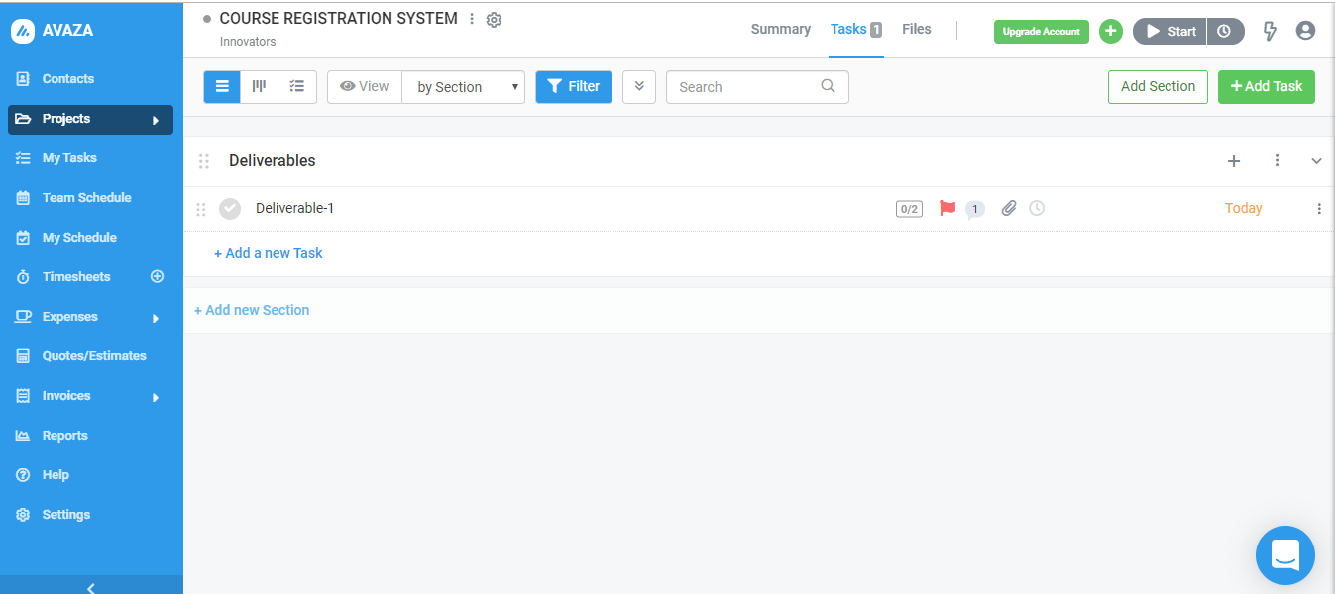

**PROJECT REPOSITORY CHECKOUT AND UPDATE POLICIES**

We use GitHub to maintain our project repository. We created a basic project structure in our local Spring tool suite IDE, cloned our GitHub repository to Spring tool suite and pushed the project to GitHub. As we continue to develop on the existing project structure, each one of us commit the code which is ready to be pushed to our GitHub repository so that all of us are on the same page. We communicate before every single commit to avoid conflicts while pulling the code from repository into our locals.